ASSIGN-1 DOCKER (FREESTYLE)
GitHub repo → Jenkins → Docker → HTML page visible in browser
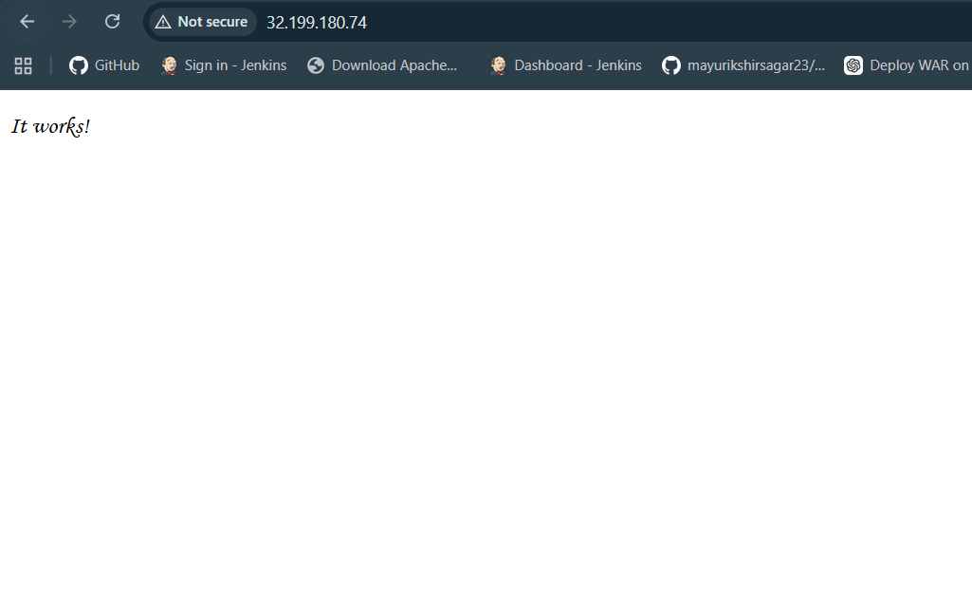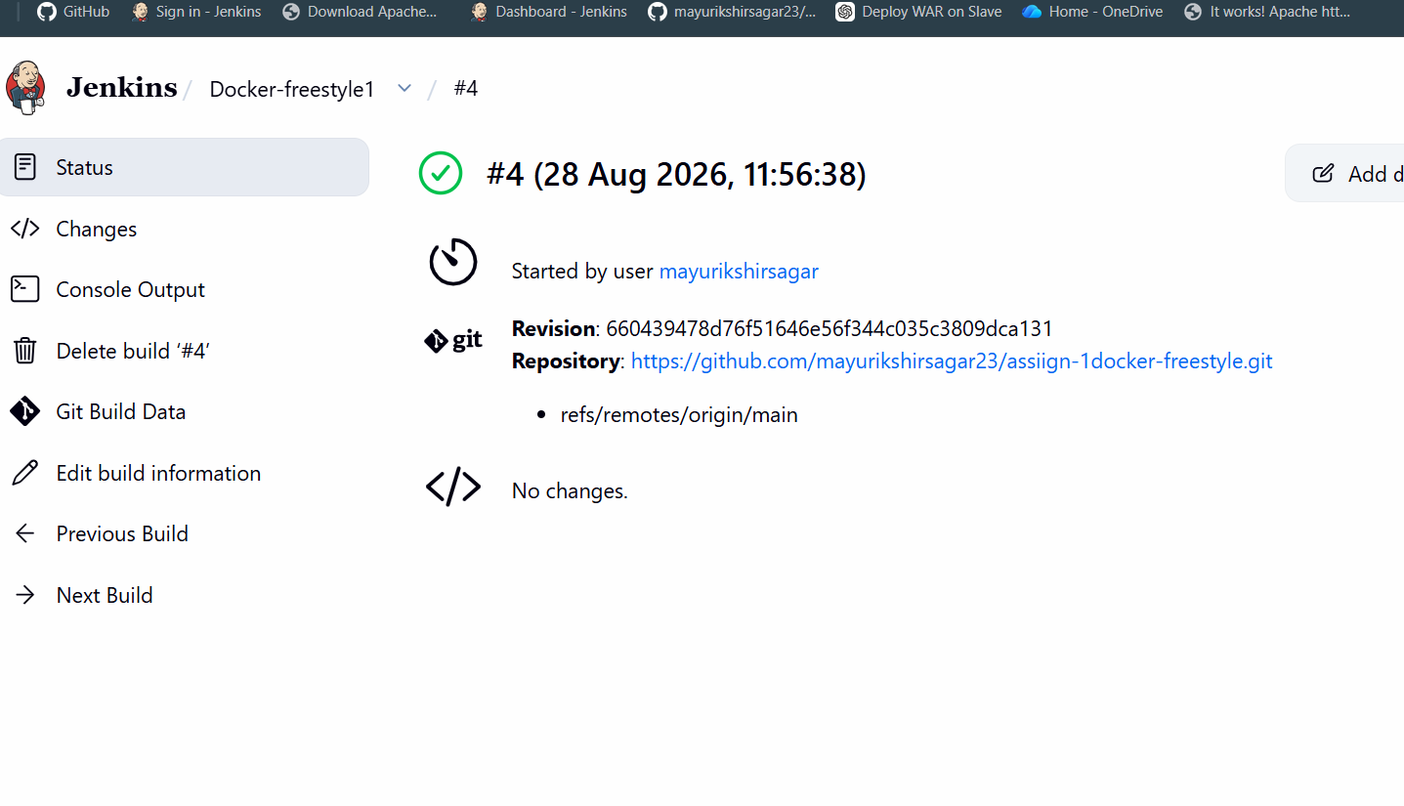

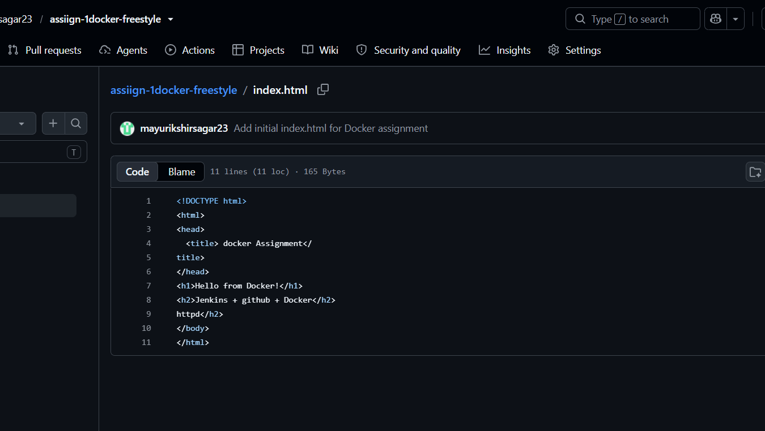

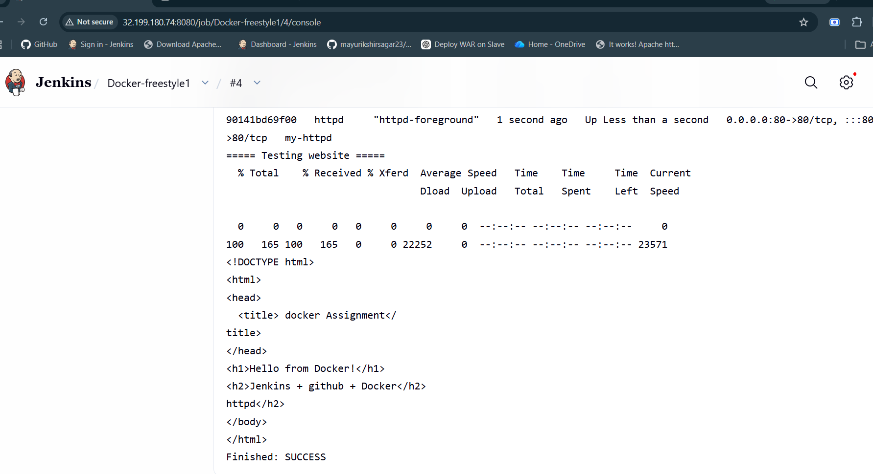

GitHub
|
| index.html
|
v
main branch
|
v
Jenkins
|
+---- Freestyle
|
+---- Pipeline
|
v
Deploy in Container
|
v
httpd

